The Secondary Structure Prediction of RNA

Abstract
Many different types of RNAs, such as mRNA, tRNA, rRNA and viral RNA, each with the different function. It is well known that the function of an RNA is determined by its three-dimensional structure. Hence, knowing the three-dimensional structures of RNAs is important for us to understand their functions.
- Introduction
- RNA
RNA is a single-strand of nucleotides (bases) adenine(A), guanine(G), cytosine(C) and uracil(U).

Primary Structure, Secondary Structure, Three-Dimensional Structure.
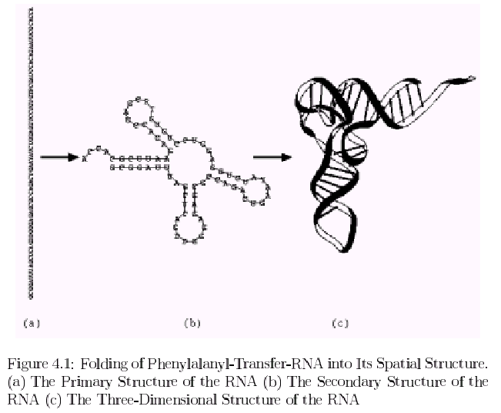
In RNA, there are three base pairs, A≡U and G=C(called Watson-Crick base pairs) and G─U (called wobble base pairs), can fold back on itself to form its secondary structure by these hydrogen bonds.

Example: A-G-G-C-C-U-U-C-C-U
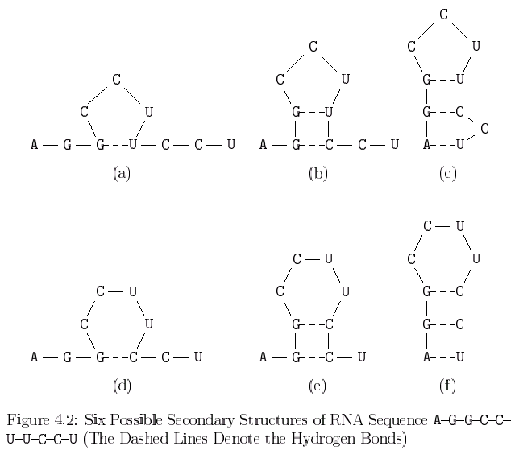
How to find the actual structure ? In nature, only the stable structure can exist and the stable structure must be the one with the minimum free energy.

- Secondary Structure of RNA
An RNA sequence will be represented as a string of n characters R = r₁r₂…r_{n}, where r_{i} ∈ {A, C, G, U}. A secondary structure of R is a set S of base pairs(r_{i}, r_{j}), where 1 ≤ i < j ≤ n, such tha the following conditions are satisfied.
- j – i > t, where t is a small positive constant. Typically, t = 3.
- If (r_{i}, r_{j}) and (r_{k}, r_{l}) are two base pairs in S and i ≤ k, then either
  - i = k and j = l, i.e., (r_{i}, r_{j}) and (r_{k}, r_{l}) are the same base pair,
  - i < j < k < l, i.e., (r_{i}, r_{j}) precedes (r_{k}, r_{l}), or
  - i < k < l < j, i.e., (r_{i}, r_{j}) includes (r_{k}, r_{l}).
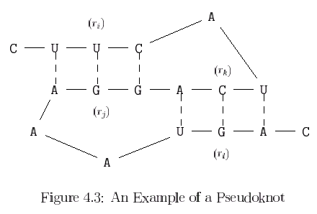
- The RNA Maximum Base Pair Matching Algorithm
S_{i,j} denote the secondary structure of the maximum number of base pairs possible on the substring r_{i}r_{i+1}…r_{j}
p(r_{i}, r_{j}) = 1 if (r_{i}, r_{j}) is a base pair.
M_{i,j} is the size of S_{i,j}
Case 1: In the optimal solution, r_{j} is not paired with any other base. In this case, find an optimal solution for r₁r₂…r_{j-1} and M_{i,j} = M_{i,j-1}.
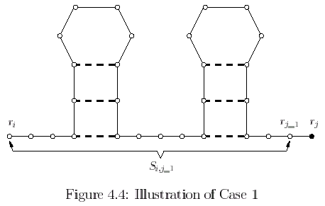
Case 2: p(r_{i}, r_{j}) = 1. Find an optimal solution for r₂…r_{j-1} and M_{i,j} = 1 + M_{i+1,j-1}
Case 3: p(r_{k}, r_{j}) = 1 where i+1≤ k ≤ j-4.
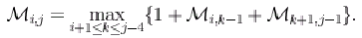
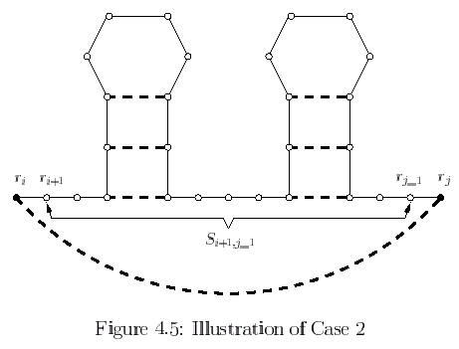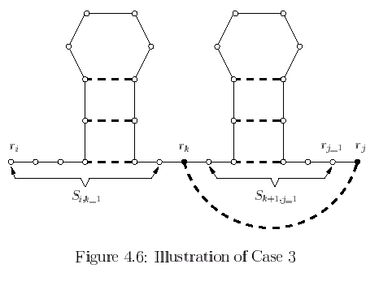
Using dynamic programming technique to compute M_{1,7}
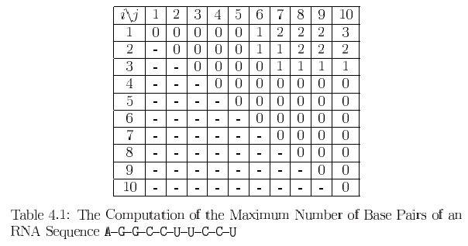
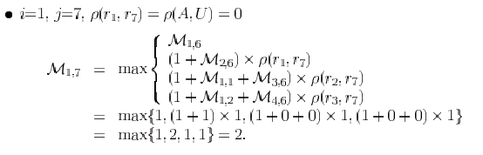
Algorithms:
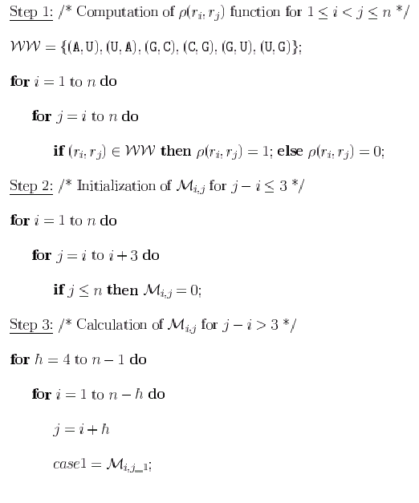
Total time-complexity of algorithm is O(n³).

- Loop Dependent Free Energy Rules
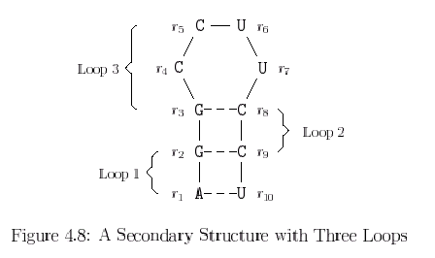
Define:
Size: the number of unpaired bases.
Degree: the number of base pairs in loop.
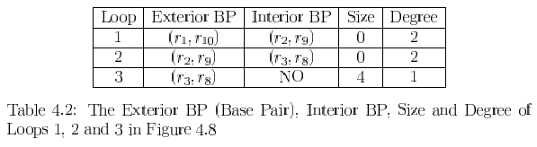
according to the degree and size, the loops can be further distinguished as one of the following different types.
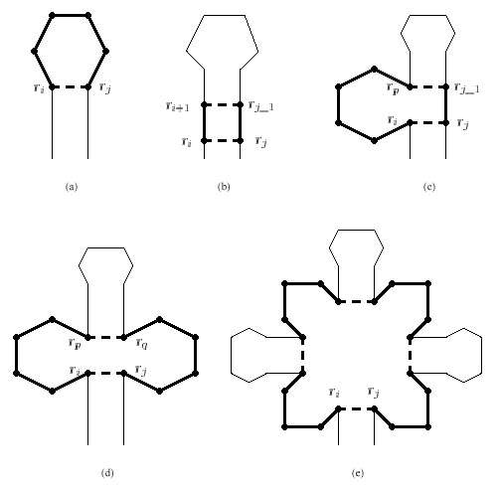
- Hairpin loop
- Stacked pair
- Bugle loop
- Interior loop
- Multiloop
In a secondary structure, the collection of adjacent unpaired bases which are not accessible by any base pair is called an external element. For convenience, we can view the external element as a special type of loop, call an exterior loop.
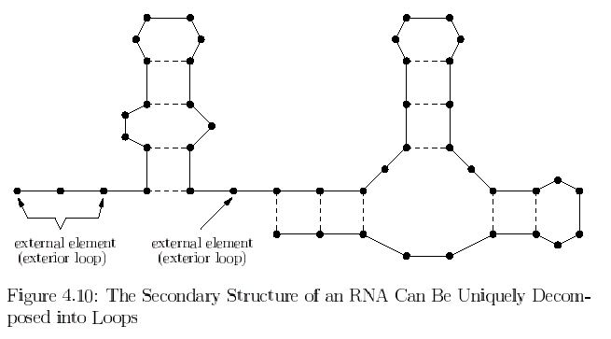
We use the following notation to denote the energies of various loops.
- Hairpin loops: H(k), the energy of a hairpin loop with size k.
- Stacked pairs: S.
- Bulge loops : B(k), the energy of a bugle loop with size k.
- Interior loops: I(k), the energy of a interior loops with size k.
- Multiloop: M = M_{E} + M_{I}×(degree –1) + M_{B}×size.
- Minimum Free Energy Algorithm
Define:
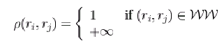
S _{i,j} : the optimal structure of the substring r_{i}r_{i+1}…r_{j}
Є_{i,j} : the free energy of S _{i,j}.

Case1 : In the optimum solution, r_{j} is not paired with any other base.
Є_{i,j} = Є_{i,j-1}.

Case2 : In the optimum solution, p(r_{i}, r_{j}) = 1.
Є_{i,j} = F_{i,j}. F_{i,j} is the minimum free energy.

Case3 : In the optimum solution, p(r_{j}, r_{k}) = 1, where i+1≤ k ≤ j-4.
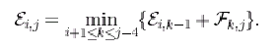
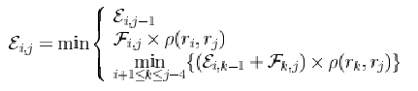
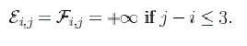
How to compute F_{i,j}??
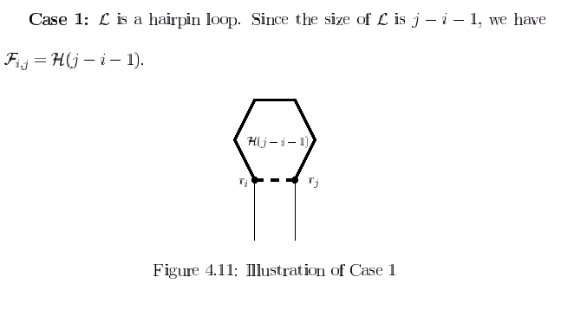
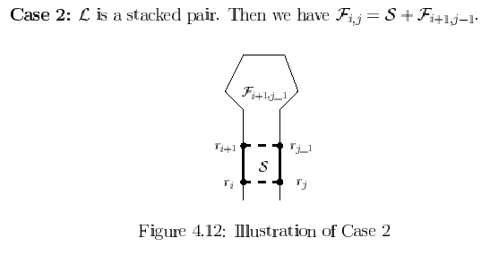
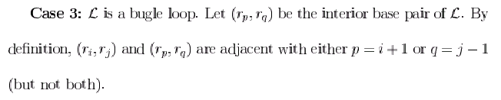
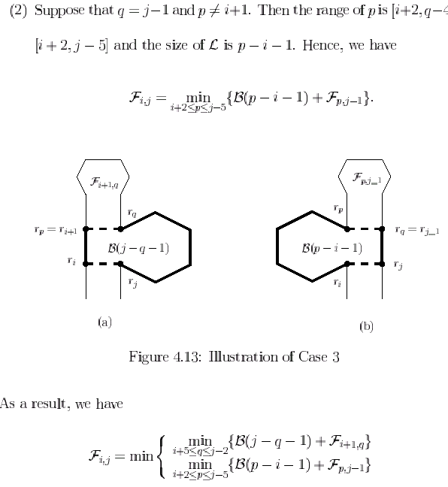
Case 4: L is an interior loop.
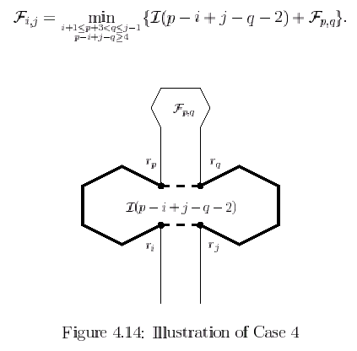
Case 5: L is a multiloop, we can represent the minimum free energy of L as follows.
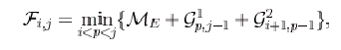
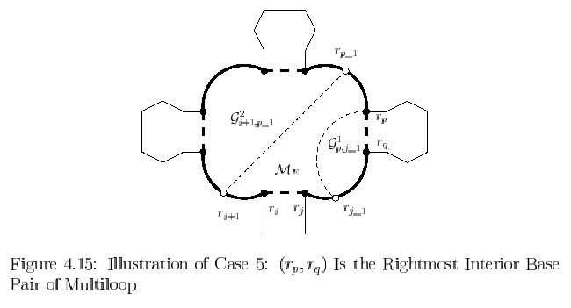
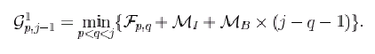
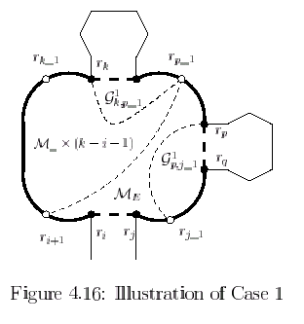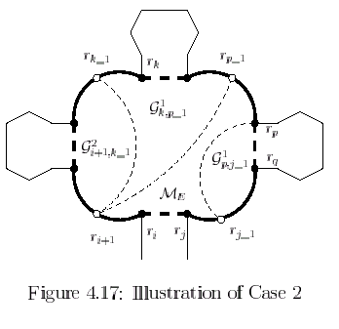
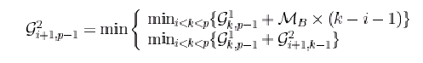
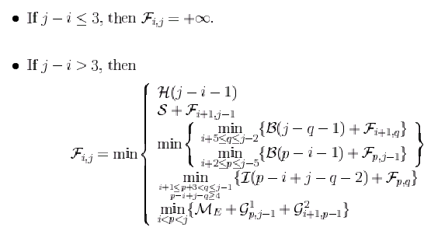
Dynamic programming algorithm.
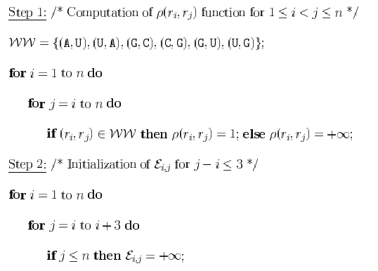
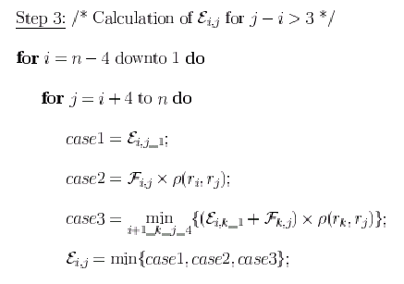
The total time-complexity of algorithm is O(n⁴).

